
NATIONAL SCIENCE FOUNDATION
OFFICE OF THE
ASSISTANT DIRECTOR
FOR MATHEMATICAL AND
PHYSICAL SCIENCES

4201 WILSON BOULEVARD
ARLINGTON, VIRGINIA 22230

October 21, 2004

Dear Members of the MPS Advisory Committee:

The time for our November 2004 meeting is fast approaching. We have a full agenda that should make for a very interesting, valuable meeting. In keeping with the wishes you expressed last spring, we are providing more extended background information in advance of the meeting, along with an indication of the types of advice we need most at this point.

I want to welcome new members to the Mathematical and Physical Sciences Directorate Advisory Committee (MPSAC): Lars Bildsten (University of California, Santa Barbara), Susan Coppersmith (University of Wisconsin), Sol Gruner (Cornell University), Robert Kohn (New York University), Steve Koonin (British Petroleum), Eve Ostriker (University of Maryland), David Oxtoby (Pomona College), and Elizabeth Simmons (Michigan State University). The term of their appointments is from October 1, 2004 through September 30, 2007.

Carl Lineberger has graciously accepted my invitation to become Chair of the MPSAC, effective October 1, 2004. The MPS staff and I have worked with him in developing the agenda and look forward to a continuing productive relationship. I want especially to thank Jeanne Pemberton for her service as the Chair of the MPSAC. Under her leadership we have made substantial progress in involving the MPSAC more actively in MPS long-range planning activities and in developing productive and ongoing relationships with EHR and its Advisory Committee.

The MPSAC meeting will take place Wednesday, Thursday, and Friday, November 3-5, 2004. The meeting will begin with a special session for new members of the MPSAC on the morning of Wednesday, November 3, where they will be briefed on activities of NSF, MPS, and Divisions within MPS. Continuing members are also welcome to attend these briefings.

The meeting will concentrate on planning for the FY 2007 budget with particular attention to planning for major facilities. As I said earlier, the MPSAC has begun to take a much more active role in the long-range planning activities of the Directorate. It is my hope that at this meeting these activities can be expanded.

For the past several years Congress has expressed concern about the NSF’s stewardship of its facilities. This is of particular interest to our Directorate as a significant number of these facilities are supported within MPS. Because of this, I have scheduled a session for us to learn about and discuss the MPS facilities. While we will provide background on our existing facilities, the focus of MPSAC discussions will be on the MPSAC role in planning for new facilities.

Presentations of the Joint Subcommittee on Undergraduate Education report, the Nanoscale Science and Engineering Committee of Visitors report, and the MPS Theory and Cyberscience workshops will provide additional input to our discussions of planning for FY 2007 and beyond. Discussions within the Divisional breakout sessions will also focus on the FY 2007 budget. All this will feed into our planning discussions on Friday.

Briefing materials for previous meetings are posted on the MPSAC web page at http://www.nsf.gov/mps/mpsac/mpsac_welcome.cfm under “Past Meeting Documentation.” Materials for the November meeting are being posted now.

Dr. Morris Aizenman, the Senior Science Associate in MPS, serves as a liaison between the Advisory Committee and the MPS Directorate. Should you have questions or suggestions concerning activities of the Committee, please contact him at 703-292-8807 or by email at maizenma@nsf.gov .

For your information, I am enclosing a copy of the charter of the Advisory Committee and a membership list effective October 1, 2004. I am also attaching a conflict-of-interest form that new members and members who are continuing on the committee after October 1 must complete prior to the November 2004 meeting. Although you may have filled one out in the past, it is important that this be updated, as we must provide these forms annually to NSF’s Office of General Counsel. The form should be sent to my secretary, Ms. Margaret-Anne Mazzi Wampamba, who has already sent new and continuing members a preliminary email concerning travel and hotel arrangements. She may be reached at 703-292-8800 or by email at mwampamb@nsf.gov.

Finally, I’d like to thank the members who are rotating off of the Committee for all of their efforts on behalf of MPS over the last three years. Those leaving the Committee are Thomas W. Appelquist (Yale University), Roger Blandford (Stanford University), Robert Hilborn (Amherst College), Jeanne Pemberton (University of Arizona), Bill Pulleyblank (T. J. Watson Research Center), and Joe Salah (Massachusetts Institute of Technology).

I look forward to an active and productive meeting.

Sincerely yours,

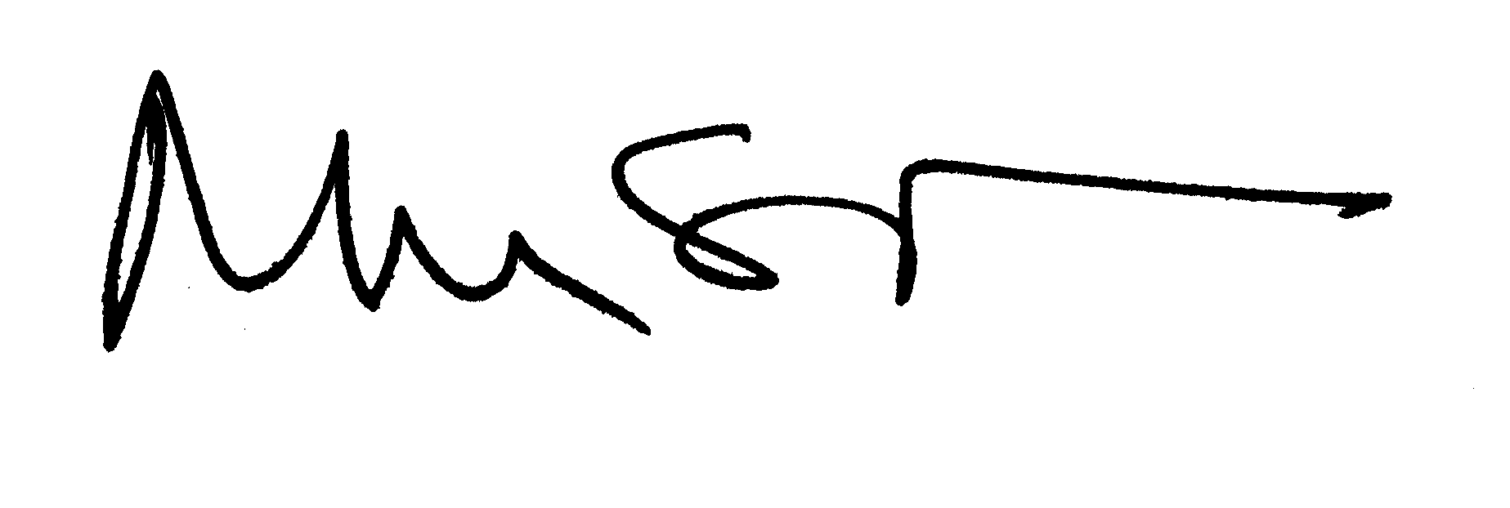

Michael S. Turner
Assistant Director

