Terrestrial ecology

NEON light

A 30-year plan to study America’s ecology is about to begin
Aug 25th 2012 | Boulder, Colorado | from the print edition
THE phrase “Big Science” brings to mind rockets, telescopes and particle accelerators. When it comes to grand scientific gestures—and the cash that goes therewith—those who wield field glasses and butterfly nets in the name of terrestrial ecology seldom get a look in. Which is surprising, as the habitat they study, namely dry land, is the one actually occupied by humanity. But a group of American ecologists, led by David Schimel, intend to correct this state of affairs. They plan to shake up terrestrial ecology, and introduce it to the scale and sweep of Big Science, by establishing NEON, the National Ecological Observatory Network.
Finding the money for this project, which will be based in Boulder, Colorado, has not been easy, but after a decade of discussion and planning, America’s National Science Foundation managed to persuade Congress to earmark $434m, the price of a modest space probe, to set it up. The operating budget will be around $80m a year.
Dr Schimel’s team is thus now starting to wire up the landscape. Ground has already been broken at three sites—in Colorado, Florida and Massachusetts. Eventually, 60 places across the country will be covered simultaneously. Once this network is completed, in 2016 if all goes well, 15,000 sensors will be collecting more than 500 types of data, including temperature, precipitation, air pressure, wind speed and direction, humidity, sunshine, levels of air pollutants such as ozone, the amount of various nutrients in soils and streams, and the state of an area’s vegetation and microbes.
Crucially, these instruments will take the same measurements in the same way in every place. By gathering data in this standardised way, and doing so in many places and over long periods of time, Dr Schimel hopes to achieve the statistical power needed to turn ecology from a craft into an industrial-scale enterprise. The idea is to see how ecosystems respond to changes in climate and land use, and to the arrival of new species. That will let the team develop models which can forecast the future of an ecosystem and allow policymakers to assess the likely consequences of various courses of action.
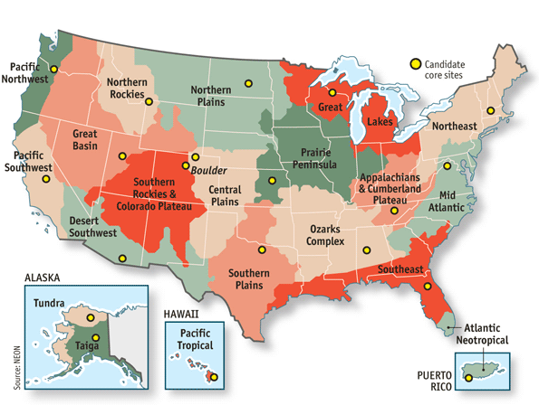
Tower records
NEON’s researchers have divided America into 20 domains (see above), each of which is dominated by a particular type of ecosystem. Each domain will have three sets of sensors within it. One set will be based in a core site—a place where conditions are undisturbed and likely to remain so—that will be monitored for at least 30 years. The other two sets will move around, staying in one place for three to five years before being transplanted elsewhere. These “relocatable” sites will allow comparisons to be made within a domain.
Every site, whether core or relocatable, will have a sensor-laden tower that reaches ten metres above the existing vegetation. In an area of a few tens of square kilometres around this tower, the researchers will place further sensors in the soil and in local streams, to measure temperature, carbon-dioxide and nutrient levels, along with rates of root growth and the activities of microbes. These sensors will indicate how efficiently different ecosystems use nutrients and water, how vegetation responds to the climate, and how carbon dioxide moves between living things and the atmosphere. That will help those who seek to understand the carbon cycle—and with it, the consequences of greenhouse-gas-induced climate change.
To complement these ground-based measurements, which can focus on only a limited area, the team will conduct aerial surveys once a year at each core site, looking at things like leaf chemistry and the health of forest canopies, and will also look down on them with satellites. In addition, NEON’s researchers can deploy a specially equipped aeroplane, fitted with lidar (an optical version of radar), a spectrometer (to measure chemical compositions) and a high-resolution camera, to assess the impact of natural disasters such as floods, wildfires and outbreaks of pests.
This aerial-surveillance system will be put to the test in a project that started on August 21st, when a team led by Tom Kampe and Michael Lefsky began studying the causes and impact of what has come to be known as the High Park fire. Between June 9th and early July this fire burned across 36,000 hectares (90,000 acres) of Colorado. Dr Kampe and Dr Lefsky will fly NEON’s aeroplane over both the burned area and some adjacent unburned stands of forest. They will record plant species, forest structure, ash cover, soil properties, river sediment and the overall topography of the burned area.
One particular question they plan to address is whether the behaviour and severity of the High Park fire was affected by the spread of mountain pine beetle, a pest that is rapidly overrunning Colorado because its breeding season has been extended by the warming climate. Repeated aerial surveys over the coming years will also give the researchers insight into how vegetation recovers from fires, how the beetles affect this process, how erosion and sedimentation affect the region’s water resources, and whether fire creates opportunities for new species to invade.
So many data, of course, require a lot of number crunching. Indeed, it might be argued that what truly distinguishes Big Science from the small stuff—as astronomers and physicists have known for decades and biologists discovered in the aftermath of the Human Genome Project—is not the amount of money involved but the volume of data that needs to be processed. When fully operational NEON is expected to generate 200 terabytes a year. That is four times as much as the Hubble space telescope, a reasonably big piece of science, churned out in its first two decades.
NEON, then, truly does represent a shift by ecologists towards bigness. No doubt that will change the practice of the subject, just as astronomy, physics and genetics changed when they became big. The days of field glasses and butterfly nets may thus be numbered. But no one doubts that in those other cases, the change was for the better. The chances are, that will be true for ecology as well.
from the print edition | Science and technology

