NATIONAL SCIENCE FOUNDATION

4201 Wilson Boulevard, Arlington, Virginia 22230

FINDING OF NO SIGNIFICANT IMPACT (FONSI)

1. Introduction
Northern Arizona University proposes to construct and operate the Merriam-Powell Research Station (MPRS) in collaboration with and on property leased from The Arboretum at Flagstaff. This project is funded by the National Science Foundation (NSF), which is the federal lead agency for the environmental review process. The environmental review process was conducted in accordance with the National Environmental Policy Act (NEPA) and other applicable federal laws, including the National Historic Preservation Act (NHPA), the Endangered Species Act (ESA), and each statute’s applicable implementing regulations. The proposed research station will provide facilities for visiting researchers, students, instructors, and agency personnel. This FONSI sets forth the NSF consideration of environmental and other factors associated with construction of the MPRS at The Arboretum at Flagstaff.
An Environmental Assessment (EA) was prepared to evaluate the potential environmental effects from the construction and operation of the proposed MPRS. The environmental review process was conducted in accordance with the Council on Environmental Quality’s procedural requirements for implementing NEPA at 40 Code of Federal Regulations (CFR) Parts 1501–1508, and NSF regulations at 45 Code of Federal Regulations (CFR) Part 640, Compliance with NEPA. The NSF sought public involvement in the NEPA process by publicizing the Draft EA and soliciting comment. The EA was finalized after the consideration of comments on November 18, 2005.
NSF also initiated and completed numerous consultations for the MPRS project. NSF engaged in informal consultation with the United States Fish and Wildlife Service, pursuant to Section 7 of the ESA, and obtained that agency’s concurrence with NSF’s determination that the MPRS project “may affect, but is not likely to adversely affect” the Mexican Spotted Owl. NSF also consulted with several Native American Tribes, the Arizona State Historic Preservation Officer (SHPO), and other interested entities under Section 106 of the NHPA. All responsive parties including the SHPO and five tribes concurred with NSF’s determination that the undertaking would have no adverse effect on historic properties. All consulting parties were extremely supportive of the project.
Based on the analysis in the EA and the above-described consultations, NSF has decided to fund the preferred alternative – the Arboretum alternative.

2. Purpose and Need
The Merriam-Powell Research Station (MPRS) of Northern Arizona University provides facilities for researchers and students carrying out fieldwork in Northern Arizona in partnership with The Arboretum at Flagstaff and Northern Arizona University’s Centennial Forest. In an effort to increase research activity and research partnerships in Northern Arizona, the MPRS plans to construct a facility that will allow it to house researchers and students in a supportive environment that encourages interaction among individuals and institutions. MPRS will use this hub of activity to promote connections of researchers with area agencies and non-profit organizations concerned with the environment. The planned MPRS housing facility is expected to support researchers working on NAU’s Centennial Forest, Arboretum land, Coconino National Forest, and Diablo Trust Lands.
By providing facilities conducive to field research and education Northern Arizona University will be filling an unmet need in Northern Arizona. NSF will be fulfilling its mission of federal support for basic science by funding an activity that will provide the infrastructure for contemporary research in biology. Field stations are crucial to efficient field research and education because they drastically reduce the logistical problems associated with housing, board, equipment storage and access to field sites. These MPRS facilities are tailored to the needs of field researchers and courses. For instance, every room does not need a private bath, and single beds are more in demand than double beds. On the other hand, having storage for field equipment, a place to cook, and computer access are usually very important to field researchers. Finally, by concentrating research and education users at a field station, a small, and highly interactive, academic community is developed. In the case of MPRS and NAU, this community will help engage colleagues from the region and the world in research collaborations.
The Final EA contains site-specific analyses of potential environmental effects that could result from installation and operation of the MPRS at the Arboretum at Flagstaff. The Final EA also analyzes the no-action alternatives for comparison purposes. Based on the analyses contained in the Final EA, as well as on the information resulting from the consultations under the ESA and the NHPA, NSF has determined that no significant environmental impact would result from implementation of the proposed action at any of the alternative sites. NSF has decided to fund the preferred alternative – the Arboretum alternative.
The MPRS will obtain a permit from the Arizona Department of Environmental Quality for the design and operation of the septic system. A FONSI is warranted for this action in accordance with NEPA. Copies of the Final EA may be obtained by written or email request to:
Amy Whipple
Merriam-Powell Center for Environmental Research
Northern Arizona University
PO Box 5640
Flagstaff, AZ 86011
or
Amy.Whipple@nau.edu

3.Decision and Order
The NSF has carefully considered its goals and objectives in relation to construction of the MPRS at the Arboretum at Flagstaff, as discussed and evaluated in the Final EA, this FONSI, and all related NHPA and ESA documentation. This consideration includes the purpose and need for the MPRS, possible alternative sites, information on possible impacts collected during the environmental and cultural resource review process, and mitigation measures to eliminate or reduce possible environmental effects. Under the authority delegated to me by the Director of the NSF, I find that construction of the MPRS at the preferred site on the Arboretum at Flagstaff will not result in significant environmental impacts. Therefore, preparation of an environmental impact statement is not necessary.

The availability of this FONSI and the Final EA is announced in the Federal Register, and the documents are available on the NSF website (http://www.nsf.gov/bio/pubs/reports/ea_mprs.doc) or by request to Amy Whipple at the above address.

Machi F. Diworth, Ph.D. Date: November 18, 2005
Director
Division of Biological Infrastructure
Directorate for Biological Sciences
National Science Foundation

FINAL
Environmental Assessment for Northern Arizona University’s Merriam-Powell Research Station

National Science Foundation
November 18, 2005

PURPOSE AND NEED
The Merriam-Powell Research Station (MPRS) of Northern Arizona University provides facilities for researchers and students carrying out fieldwork in Northern Arizona in partnership with The Arboretum at Flagstaff and Northern Arizona University’s Centennial Forest. In an effort to increase research activity and research partnerships in Northern Arizona, the MPRS plans to construct a facility that will allow us to house researchers and students in a supportive environment that encourages interaction among individuals and institutions. MPRS will use this hub of activity to promote connections of researchers with area agencies and non-profit organizations concerned with the environment. The planned MPRS housing facility is expected to support researchers working on NAU’s Centennial Forest, Arboretum land, Coconino National Forest, and Diablo Trust Lands.

The planned MPRS housing facility consists of a ~3500 sq. ft. housing structure with bunk rooms, bathrooms, great room, kitchen, mudroom, and an attached 2 bedroom “apartment” (Appendix A). The MPRS expects the facility to house 20-30 people through most of the peak field season of May-September. Use will be more sporadic through the off-season. Build-out for the MPRS housing may lead to a doubling of the currently planned capacity. Laboratory and greenhouse spaces are being provided in existing Arboretum structures.

The proposed construction site is on the property of The Arboretum at Flagstaff which owns ~200 acres southwest of the City of Flagstaff on Woody Mountain Road (Appendixes B-D). The site is owned by The Arboretum at Flagstaff, which is a §501 c(3) non-profit organization governed by a board of directors. The Arboretum will enter into a long-term lease with the Arizona Board of Regents of approximately 5 acres for the purpose of constructing and running the MPRS facility. The Arboretum property is surrounded, primarily, by the Coconino National Forest and by Arizona State Trust land that is also designated as NAU’s Centennial Forest. The planned construction site is adjacent to: 1) a City of Flagstaff well, 2) The Arboretum at Flagstaff’s maintenance building, 3) The Arboretum’s greenhouse, and 4) The Arboretum’s Nature Trail.

By providing facilities conducive to field research and education the MPRS will be filling an unmet need in Northern Arizona. Field stations are crucial to efficient field research and education because they drastically reduce the logistical problems associated with housing, board, equipment storage and access to field sites. These MPRS facilities are tailored to the needs of field researchers and courses. For instance, every room does not need a private bath, and single beds are more in demand than double beds. On the other hand, having storage for dirty field equipment, a place to cook, and computer access are usually very important to field researchers. Finally, by concentrating research and education users at a field station, a small, and highly interactive, academic community is developed. In the case of MPRS and NAU, this community will help engage colleagues from the region and the world in research collaborations.

MPRS housing use estimates have been developed based on survey returns and other expressed interest in use of the MPRS. Because of the incomplete distribution and potential for lack of response from interested, but busy, individuals the MPRS feels that the use estimates based on the survey are conservative. The MPRS expects that within a few years of opening, the housing facility will have 2500 user nights per year. The MPRS also expects users to include: summer researchers (graduate student and faculty), short-term researchers, undergraduate researchers, university courses (visiting and NAU), and mission-related workshops. The MPRS plans to have all station use be mission related. This would include research, education, and outreach on environmental or field research topics. Thus, the MPRS will not run into issues of competing with local businesses.

ALTERNATIVES

Alternatives eliminated from detailed study: The originally proposed location for the MPRS was to the east of the current site on State Trust Land operated as Northern Arizona University’s Centennial Forest (Appendix D). This alternative was eliminated from detailed study because: 1) it was closer to a Mexican Spotted Owl Protected Activity Center, 2) it was more costly both in money and environmental footprint because supporting infrastructure was less available and utilities had to be extended further, and 3) a local land owner and State Trust Land lessee was concerned about impacts to his property and activities.

Another proposed location on State Trust Land south of Woody Mountain Road was deemed by the NAU administration to not to meet the project goals due to the cost of extending infrastructure and the distance from Arboretum resources.

No action alternative: The no action alternative provides a baseline with which to compare proposed activities. Under the no action alternative the proposal would be withdrawn and housing facilities for the MPRS housing facility would not be constructed.

The Arboretum alternative: In the Arboretum alternative NAU will construct and operate the 3500 square foot MPRS housing facility on land leased from The Arboretum at Flagstaff on Woody Mountain Road, southeast of Flagstaff.

The Arboretum alternative is the preferred alternative.

Environmental Consequences

NO ACTION ALTERNATIVE:

There would be no impacts to any of the below resources. This would include the absence of potential benefits to the environment from research and education promoted through the MPRS housing facility.

ARBORETUM ALTERNATIVE:

Air Quality/Transportation:
The only air quality concerns are the dust associated with construction and transportation. The site is small and well protected and dust is not expected to be a significant construction problem. Any environmental impact due to dust during construction will be mitigated by controlling the dust with water as needed. Dust associated with traffic on Woody Mountain Road is a concern for Coconino County. Dust created by MPRS users of Woody Mountain Road will be mitigated via participation in a formalized dust mitigation plan for the road with The Arboretum at Flagstaff and other users as requested by the county and written into the recently obtained conditional use permit for the site. Currently, The Arboretum contributes to dust mitigation with occasional watering.

Light Pollution:
Flagstaff is a Dark Skies city, in part, in order to minimize light pollution impacts on area observatories. All MPRS lighting will be shielded as recommended by City of Flagstaff guidelines to avoid impacts even thought the project is not in the city. The site has additional shielding from the many surrounding trees that will be left in place.

Heritage Resources and Environmental Justice:
The Cultural Resource report found no indication of historical or archeological artifacts and no evidence of eligible sites within the area of potential effect. The NSF has issued a finding that the proposed project will have “no effect” on historic resources, and received concurrence with this finding from the Arizona State Historic Preservation Officer. NSF is similarly seeking concurrence from several federally recognized Indian Tribes. The Fort Apache, Hopi, Navajo, Yavapai-Prescott, and Zuni tribes responded positively and no negative responses were received. The cultural resource report, letter to SHPO office, letter to tribes, and tribal distribution list can be found as Appendixes E-H.

The project area is surrounded by non-residential properties and is not foreseen to have differential impacts on minority or disadvantaged populations.

Recreation and Socioeconomic:
The project will not adversely impact recreational use of the area. Users of MPRS may make use of existing and future trails described in the Environmental Assessment for the Woody Ridge Forest Restoration Project. Research conducted at MPRS will be interpreted for the public at The Arboretum at Flagstaff and thus contribute to visitor experiences. As most of the users of the MPRS are expected to be new users of Northern Arizona research and education resources, and all use will be mission related, there will not be a negative impact on area businesses.

Water Resources:
Significant effects on surface water are not expected. The area of ground disturbance will be less than one acre. Fencing will be installed to ensure construction vehicles stay within this area. The site has only a very slight slope and crosses no drainages. Disturbed areas will be covered with pine needle and/or bark mulch upon the completion of construction.

The septic system is designed to meet or exceed Arizona Department of Environmental Quality’s requirements to protect water quality. An Aquifer Protection Permit will be obtained for installation and operation of the system. The distance of the septic system from the City of Flagstaff well is over 400 feet, four times the 100-foot separation required by Arizona Department of Environmental Quality standards. In addition, the septic system is down-slope of the wellhead.

Vegetation:
The area of ground disturbance from this project will be less than one acre. The existing vegetation is a Ponderosa Pine overstory and a sparse grass and forb understory. The driveway, building, parking and leach field are being located to minimize cutting of trees, especially larger trees. Areas of ground disturbance will be restored with pine needle/bark mulch. Invasive species importation will be minimized by using weed-free fill, should importation of fill be required, and by rinsing construction vehicles before they come to the site. Post-construction, invasive species will be hand-pulled from the area if present. The only plant species of concern in the area that is known to occur on Arboretum property (according to the Arboretum Flora compiled by Paul Boucher and J.M. Rominger from collections in 1975-6 with updates in 1983 by A. Neas and in 2000 by Joanne Baggs and Jan Busco; Appendix I) is Astragulus rusbyi. Plant species of concern are defined as those listed in the Environmental Assessment for the Woody Ridge Forest Restoration Project (USDA, 2004a) which covers the Arboretum area. Astragulus rusbyi is a Region 3 Forest Service Region sensitive species. It is not a threatened or endangered species. A couple of Astragulus sp. individuals were found within the construction area, though the species could not be determined because there were no flowers or fruits present. Astragulus sp. individuals within the construction site will be dug up prior to construction, maintained in a greenhouse, and replanted after construction. Additional Astragulus rusbyi will be included in post-construction plantings.

Visual Quality:
The building is designed to blend with the surroundings and existing architectural styles at The Arboretum at Flagstaff. Neutral colors and malpais rock will be used to help the structure blend with its surroundings. It will be surrounded by ponderosa pine forest and be unseen except from limited locations on State Trust land operated as NAU’s Centennial Forest and a small portions of the Arboretum’s Nature Trail. Even from these small areas the view is partially shielded by trees. This is not deemed significant because existing buildings at The Arboretum at Flagstaff could also be seen from these locations.

Wildlife:
As advised by Shaula Hedwall of the US Fish and Wildlife Service (USFWS) office in Flagstaff, Arizona, the only Threatened or Endangered Species of concern for this project is the Mexican Spotted Owl (Strix occidentalis lucida) (MSO). A section 7 consultation was undertaken, and a Biological Assessment submitted to the USFWS requesting concurrence with a finding that this project “may affect, but is not likely to adversely affect” the MSO. The Arboretum alternative site is just over 500 meters from the Dry Lake Protected Activity Center (PAC) for the MSO.

The MSO was designated as a threatened species under the endangered species act in 1993. Protected Activity Centers for the MSO are areas of preferred nesting and roosting habitats around sites where owls are known to occur. While any impact to the PAC should be avoided, breeding season disturbances are of greatest concern. MSO’s are thought to breed during the period of March 1 to August 31, although they do not nest every year and may reproduce sporadically. MSO’s most commonly nest and roost in mixed-conifer forests, dominated by Douglas fir and/or white fir, and in canyons with varying degrees of cover (Ganey and Balda 1989, USDI 1995). They also nest and roost in ponderosa pine-Gambel oak forest, where they are typically found in stands containing well-developed understories of Gambel oak (USDI 1995).

The MPRS project lies within that portion of the MSO's distribution referred to as the Upper Gila Mountains Recovery Unit (RU) (Williams 1986 in USDI 1995). Ganey et al. (2000) estimated 2,950 +/- 1,067 (SE) MSO's occur in the Upper Gila Mountains RU. One of the MSO PACs in the Gila RU is the 1,106-acre Dry Lake PAC, which includes the ridgelines east, north, and west of The Arboretum at Flagstaff property. This PAC includes U. S. Forest Service, Arizona State Trust (including Centennial Forest), and U.S. Navy lands in an arc following the steeper slopes surrounding Montoya Meadow (Appendix D).

MSO’s have been observed in the Dry Lake PAC. A pair of MSO’s may have been detected on or near the Naval Observatory by the Arizona State Land Department (ASLD) on June 28, 1994. Solitary MSO detections were reported in 1994, 1995, and most recently, in 2001 in the eastern portion of the Dry Lake PAC. The U.S. Fish and Wildlife Service speculates, based on a 1995 radio-telemetry study, that MSO may use the area as an east-west dispersal corridor.

The distance from the construction site to the Dry Lake PAC on State Trust Land is approximately 500m. The septic leach field may be as close as 450m to the PAC while the building will be 500m away. The intervening land is a combination of ponderosa pine forest with small clearings/areas of meadow. Due to the fact that the building will occur on an already developed site and will not remove/impact MSO habitat, we have been mainly concerned with the potential for noise to disturb MSO associated with the PAC. The planned construction site is adjacent to: 1) a City of Flagstaff well, 2) The Arboretum at Flagstaff’s maintenance building, 3) The Arboretum’s greenhouse, and 4) The Arboretum’s Nature Trail. Due to the existing uses by the Arboretum and the visiting public and due to the distance from the PAC, increases in day-to-day human activity in the area are not expected to significantly increase noise disturbance to owls in the PAC. Any recreational use of the area by visitors will be directed toward official trails to avoid disturbance of owls in the PAC.

Two safety margins will be built into the construction plan for the MPRS housing facility to ensure that impacts of construction activity on MSO will not be significant. First, the construction site will be ~500 m from the PAC (beyond the 320m and 400m thresholds for flushing and evidence of response to road maintenance equipment, Delaney et al. 1999 and Delaney and Grubb 2003). Additionally, heavy and loud construction machinery will only be used outside of the breeding season.

With the conservation measure of restricting heavy construction activity, and its associated noise, to the non-breeding season the NSF concludes that this project “may affect, but is not likely to adversely affect” the MSO. The USFWS has concurred with this finding. Appendix J is the Biological Assessment sent to USFWS for review.

Cumulative Impacts:
PAST ACTIONS:
Arboretum site development and restoration since founding in 1981 have included:
- Horticulture Center Constructed
- Visitor Parking Lot Created
- Pond liner installed
- Public restrooms constructed
- Gardens and pathways expanded (ongoing)
- Woody Mountain Well constructed (City of Flagstaff)
- Nature trail constructed
- Constructed wetlands wastewater system installed
- Arizona Dept. of Transportation research greenhouse constructed
- Log House Relocated to property
- Facilities Building Constructed
- Greenhouse constructed adjacent to facilities building
- Ponderosa forest thinning
- Grassland restoration
- Various off-site plant conservation and restoration projects

Centennial Forest activities include the development of camping facilities south of Woody Mountain Road and research project going on across Centennial Forest.

Woody Ridge Forest Restoration project: The Coconino National Forest and Greater Flagstaff Forest Partnership’s cooperative Woody Ridge Forest Restoration project covers the Forest Service lands near the proposed site for the MPRS housing facility. This plan includes forest restoration activities such as thinning and burning designed to protect wildlife and threatened and endangered species, as well as reduce the risk of catastrophic wildfire. Thinning and broadcast burning on the Coconino Forest parcel directly south of the proposed site has already occurred as has thinning in the Dry Lake MSO PAC area north of the Arboretum. These forest restoration projects may be the subject of research by users of the MPRS and may result in better application of forest restoration techniques in the future. Otherwise, they are not expected to have any cumulative impacts with this construction project since noise and dust creating activities are separated by multiple years.

Reasonably Foreseeable Future Actions:
Woody Ridge Forest Restoration project: A desired listed project was to build a new, low impact trail for public access to Dry Lake. Dry Lake is on the east side of the Dry Lake MSO PAC and east of the Arboretum. This trail will reduce impacts from current informally trails to Dry Lake vegetation and to the MSO.

Arboretum, MPRS and Centennial Forest: These three partner institutions have tentative plans for growth depending on future levels of use. As a result of this project, MPRS may eventually wish to double housing capacity at the site and may collaborate with the Arboretum to increase research support capabilities at the site by building a science and administration building. Independently of this project, The Arboretum at Flagstaff has plans for potential development to improve visitor services and research capability though addition of a visitor center and a science and administration building. The adjacent Centennial Forest is developing research support infrastructure and youth camp facilities.

CUMMUALTIVE IMPACTS:

Air Quality/Transportation:
Past development of the Arboretum site has probably increased traffic on Woody Mountain Road and hence increased dust production. While each additional use probably has insignificant effects there may be cumulative impact of this increase. Hence the Coconino County is requiring, through the conditional use permit for the Arboretum site, that mitigation measures be taken in the form of dust abatement that take in to account all the major users of the road.

Light Pollution:
No cumulative impacts are expecting as lighting on the sites is minimal, most uses besides MPRS are daytime activities, and any added lighting for MPRS or the Centennial Forest will be shielded.

Heritage Resources and Environmental Justice:
Cultural resource effects, in this case, would be specific to the site of a development activity and not be cumulative. The project area is surrounded by non-residential properties and is not foreseen to have differential impacts on minority or disadvantaged populations.

Recreation and Socioeconomic:
Cumulatively the Woody Ridge trail development, Arboretum growth, and NAU activities could significantly increase public visitation in a manner that protects environmental resources. These visitors could have positive impacts on the area economy.

Water Resources:
The Arboretum uses significant water resources for their gardens. Research common gardens could use significant water in the future. Residential uses are very small in comparison. Mitigation of both run-off and water use are being achieved at the Arboretum through rooftop water collection from the Arboretum’s maintenance building. To prevent any cumulative impacts MPRS will invest in such a system before any additional building.

Vegetation:
Cumulative impacts on vegetation are expected to be, on balance, slightly positive when Woody Ridge Restoration, Arboretum, Centennial Forest, and Arboretum activities are considered together. While small areas of vegetation are lost to development, more acreage is restored to conditions that favor greater diversity of native plants. Many Arboretum projects work towards the maintenance or recovery of threatened or endangered plant species.

Visual Quality:
The future proposed developments cannot be seen from the same locations. Only the Arboretum core site construction activities have the potential for being visible over medium distances. The other projects are shielded by trees and by land contour. The proposed project is near some existing Arboretum buildings and will not significantly detract from the visual quality of the area due to the design and generally low visibility due to partially screening trees.

Wildlife:
As the construction activity is limited to the non-breeding season, is 500m from the Mexican Spotted Owl Protected Activity Center, and is of restricted duration it should not act in a cumulative way with other construction or forest thinning activities. The other potential for cumulative impact would be through impact of increased levels of research and recreation. Recreation should be directed to planned trails, like those in the Woody Ridge Forest Restoration Project Environmental Assessment (USDA, 2004a). Researchers coming to the area to use the MPRS will be made aware of the Protected Activity Centers and potential restrictions on activities in these areas.

CONSULTATION AND COORDINATION

This document was drafted by Amy Whipple (NAU’s MPRS) and edited by Charisse Carney-Nunes and Gerald Selzer (NSF); and Michael Wagner and Jonathan Smith (NAU’s Centennial Forest).

The supporting Cultural Resource Evaluation was conducted by Lynn Neal of Envirosystems Management Inc, Flagstaff. The NSF issued a finding that the proposed project will have “no effect” on historic resources, and received concurrence with this finding from the Arizona State Historic Preservation Officer. The Fort Apache, Hopi, Navajo, Yavapai-Prescott, and Zuni tribes responded positively to a request to review the project and no negative responses were received from Indian Tribes.

The Biological Assessment was drafted by Amy Whipple, Jonathan Smith, and Matthew Clark in consultation with Shaula Hedwall of the US Fish and Wildlife Service Flagstaff Office. It was reviewed and edited by Charisse Carney-Nunes and Gerald Selzer (NSF), and was sent to USFWS, which concurred with a Section Seven consultation determination of “may affect, but is not likely to adversely affect”. Shaula Hedwall of USFWS was also consulted on general environmental concerns in the area of the proposed project and on the original (now eliminated) alternative site.

Jonathan Smith and Michael Wagner discussed the eliminated alternative sites extensively with Arizona State Trust Land personnel.

The Arboretum at Flagstaff is involved in all major decisions about the Arboretum alternative and was involved in discussions of the eliminated alternatives.

Coconino County has been engaged through their “Conditional Use Permit” process and has approved the conditional use permit for the proposed site. Building Permits will also be obtained from the county before construction begins.

An Aquifer Protection Permit will be obtained from the Arizona Department of Environmental Quality for the septic system before its construction begins.

Input related to programmatic use of MPRS has been received from NAU researchers and faculty, researchers and faculty around the country, and from the local National Park Service office.

A public open house on the Centennial Forest on December 19, 2003, included information on the MPRS.

The Environmental Assessments for the Lowell Observatory’s Discovery Channel Telescope (USDA, 2004b) and the Woody Ridge Forest Restoration Project (USDA, 2004a), both on the Coconino National Forest were used as additional guides for potential concerns in the area. Web addresses for these documents are in the reference section.

REFERENCES CITED

Delaney, David K., T.G. Grubb, P. Beier, L. L. Patter, and M. H. Reiser. 1999. Effects of helicopter noise on Mexican spotted owls Journal of Wildlife Management 63(1):60-76.
Delaney, D.K., T.G. Grubb, 2003. Sound Recordings of Road Maintenance Equipment on the Lincoln National Forest, New Mexico. A Report to San Dimas Technology and Development Center. Rocky Mountain Research Station.
Ganey, J.L, G.C. White, A.B. Franklin, J.P. Ward, Jr., and D.C. Bowden. 2000. A pilot study on monitoring populations of Mexican spotted owls in Arizona and New Mexico: second interim report. 41 pp.
Ganey, J.L. and R.P. Balda, 1989. Distribution and habitat use by Mexican spotted owls in northern Arizona. Condor 92:485-490.
US Dept. of Agriculture, Forest Service. 2004a. Environmental Assessment for the Woody Ridge Forest Restoration Project. Coconino County, Arizona. http://www.fs.fed.us/r3/coconino/publications/woody-ridge/index.shtml
US Dept. of Agriculture, Forest Service. 2004b. Final Environmental Assessment: Lowell Observatory’s Discovery Channel Telescope. Coconino County, Arizona. http://www.fs.fed.us/r3/coconino/nepa/2004/final-ea-telescope-complete.pdf
U.S. Department of the Interior (USDI), Fish and Wildlife Service. 1995. Recovery Plan for the Mexican spotted Owl. Albuquerque, New Mexico.

LIST OF Appendixes Page
Appendix A: Proposed Building Floor Plan 11
Appendix B: Overall Arboretum Site Plan 12
Appendix C: Proposed MPRS Site Plan 13
Appendix D: Area Overview 14
Appendix E: Cultural Resource Survey 15
Appendix F: Letter to Arizona State Historic Preservation Officer 18
Appendix G: Letter to Consulted Federally Recognized Indian Tribes 21
Appendix H: MPRS Distribution List of Tribes Consulted 24
Appendix I: Arboretum Plant List 25
Appendix J: Biological Assessment 31

Appendix A: Proposed Building Floor Plan
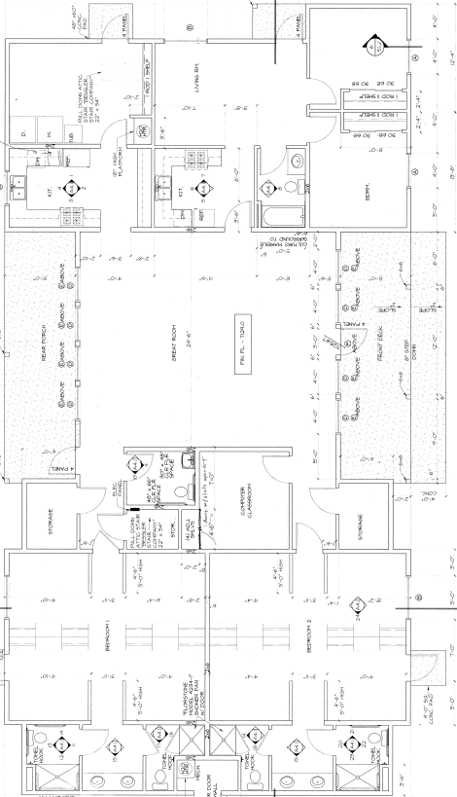
Appendix B: Overall Arboretum Site Plan
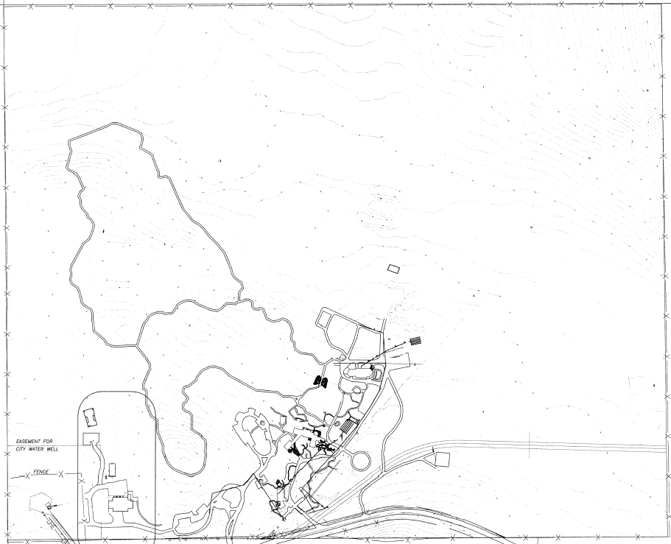

Appendix C: Proposed MPRS Site Plan
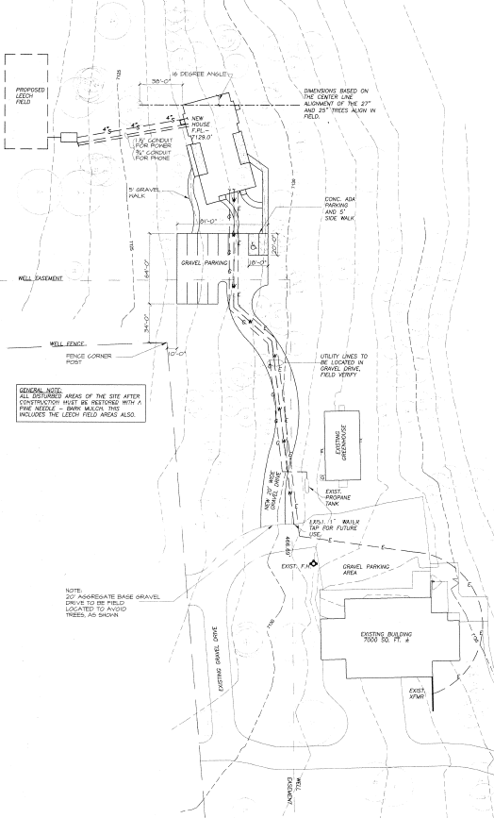

Appendix D: Area overview

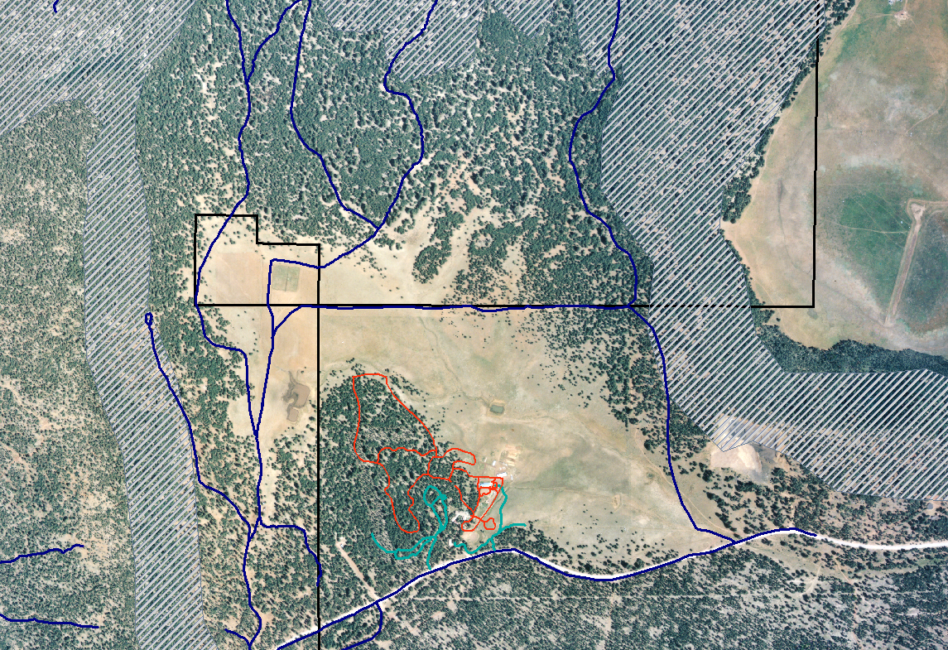
Arboretum
trails
Woody Mt. Rd.
Centennial Forest/
State Trust
PAC
PAC
PAC
PAC
= Proposed MPRS Building Site
Private
Blue lines = roads or driveways (existing)
Appendix E: Cultural Resource Survey
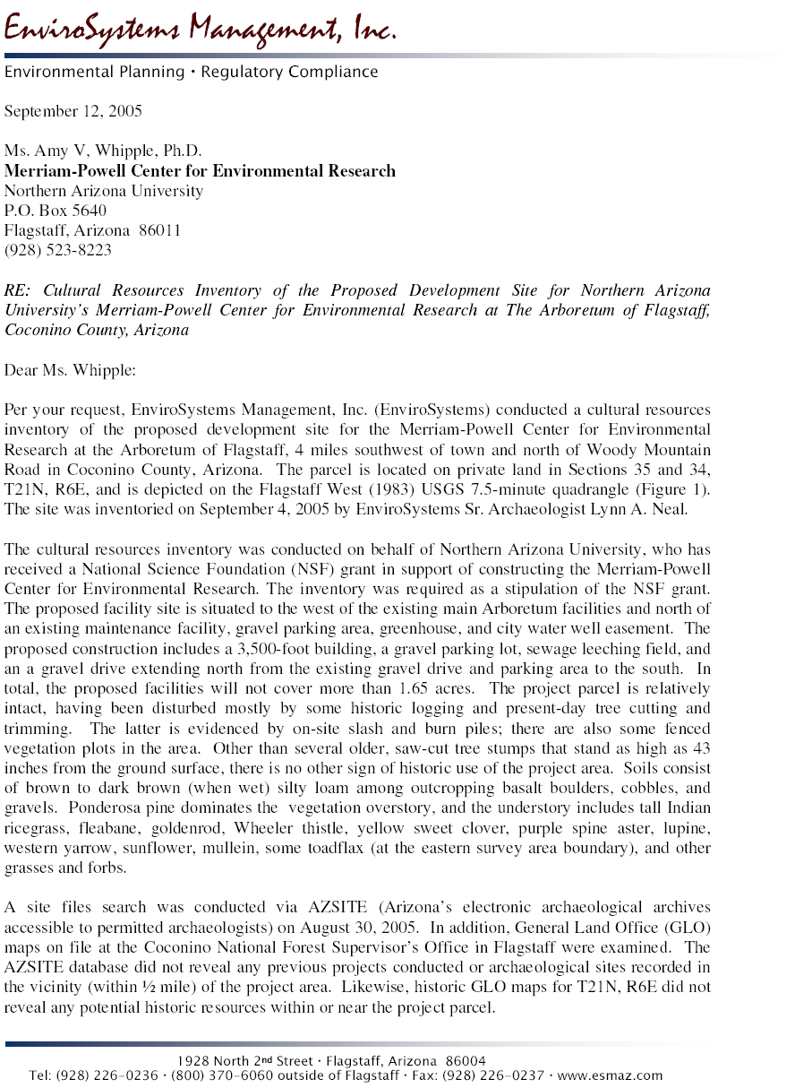

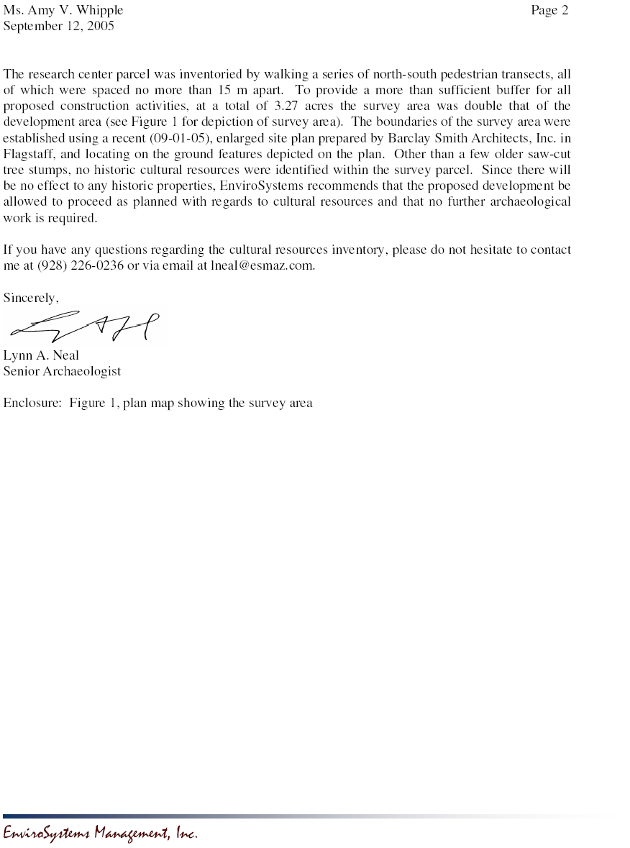
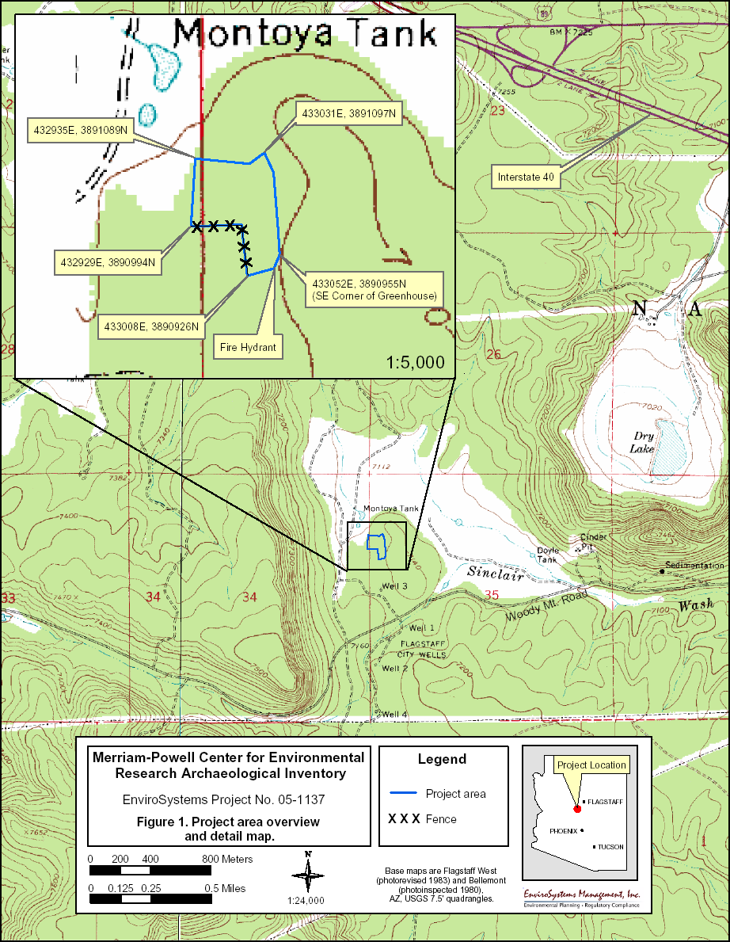
Appendix F: Text of Letter to Arizona State Historic Preservation Officer

NATIONAL SCIENCE FOUNDATION

4201 Wilson Boulevard
ARLINGTON, VIRGINIA 22230

September 23, 2005

VIA CERTIFIED MAIL – RETURN RECEIPT REQUESTED

James Garrison

State Historic Preservation Officer

Arizona State Parks

1300 West Washington
Phoenix, Arizona 85997

Dear Mr. Garrison:
The National Science Foundation (NSF) is undertaking a process pursuant to the National Historic Preservation Act (NHPA) and the National Environmental Policy Act (NEPA) for the planning, construction and operation of the Merriam-Powell Research Station (MPRS) pursuant to a proposal from Northern Arizona University (NAU) in collaboration with, and on property leased from, The Arboretum at Flagstaff. The proposed project is funded by NSF.
The proposed research station will provide facilities for visiting researchers, students, instructors, and agency personnel. It will leverage productive collaborations involving NAU researchers and the numerous field research opportunities in Northern Arizona, including the adjacent NAU Centennial Forest. The two alternative sites considered for the MPRS were on undeveloped land on the NAU Centennial Forest and adjacent to existing development at The Arboretum at Flagstaff. We expect construction to be completed by May of 2006.

NSF hereby invites your comments on the enclosed the MPRS historical and archaeological resources report for the proposed Arboretum location for the MPRS. This report was prepared by a consultant meeting the Secretary of Interior’s Professional Qualification Standards for Historic Preservation. Please be advised that we are also initiating consultation with the federally recognized Indian tribes listed in the enclosed service list for the MPRS project. The historical and archaeological resources report information will also be included in a Draft Environmental Assessment that is in preparation pursuant to NEPA. The report describes cultural considerations and analysis culminating in the the NSF’s determination with required to potential effects on historic resources.
In conformance with consultation requirements in Section 106 of the NHPA, NSF requests your comments or concerns on the proposed project. Specifically, NSF requests your concurrence with the Foundation’s determination that the proposed construction and operation of the MPRS at The Arboretum at Flagstaff will have no effect on historic resources.

Please let us know within 30 days of your receipt of this letter if you have any comments concerning the MPRS’s potential to affect cultural or Native Indian Tribal resources at The Arboretum at Flagstaff.
NSF hereby designates Amy Whipple as its authorized representative to receive your comments and to resolve any concerns that you may have. If further consultation is required under the regulations, Ms. Whipple is further authorized to negotiate on NSF’s behalf. NSF will closely oversee Ms. Whipple’s communications with you and will be legally responsible for making all required findings and determinations under Section 106 of the NHPA. Ms. Whipple’s contact information is:
Amy V. Whipple
Merriam-Powell Center for Environmental Research
P.O. Box 5640
Northern Arizona University
Flagstaff, AZ 86011
Fax: 928-523-8223
Phone:(w) 928-523-8727
(h) 928-714-0409
e-mail: amy.whipple@nau.edu
Assistant General Counsel Charisse A. Carney-Nunes of my staff has been assigned to oversee this matter for NSF. You may also contact Ms. Carney-Nunes directly with any communications, comments or concerns regarding the consultative process at 703-292-5056.

Sincerely,

Lawrence Rudolph
General Counsel

Appendix G: Sample Text of Letter to Consulted Federally Recognized Indian Tribes

NATIONAL SCIENCE FOUNDATION

4201 Wilson Boulevard

ARLINGTON, VIRGINIA 22230

September 23, 2005

Carmelita Chavez
Pueblo of Zuni
PO Box 339
Zuni, NM 87327

Dear Carmelita Chavez:
The National Science Foundation (NSF) is undertaking a process pursuant to the National Historic Preservation Act (NHPA) and the National Environmental Policy Act (NEPA) for the planning, construction and operation of the Merriam-Powell Research Station (MPRS) pursuant to a proposal from Northern Arizona University (NAU) in collaboration with, and on property leased from, The Arboretum at Flagstaff. The proposed project is funded by NSF.
The proposed research station will provide facilities for visiting researchers, students, instructors, and agency personnel. It will leverage productive collaborations involving NAU researchers and the numerous field research opportunities in Northern Arizona, including the adjacent NAU Centennial Forest. The two alternative sites considered for the MPRS were on undeveloped land on the NAU Centennial Forest and adjacent to existing development at The Arboretum at Flagstaff. We expect construction to be completed by May of 2006.

NSF hereby invites your comments on the enclosed the MPRS historical and archaeological resources report for the proposed Arboretum location for the MPRS. This report was prepared by a consultant meeting the Secretary of Interior’s Professional Qualification Standards for Historic Preservation. The historical and archaeological resources report information will also be included in a Draft Environmental Assessment that is in preparation pursuant to NEPA.
In conformance with consultation requirements in Section 106 of the NHPA, NSF requests your comments or concerns on the proposed project. Specifically, NSF requests your concurrence with the Foundation’s determination that the proposed construction and operation of the MPRS at The Arboretum at Flagstaff will have no effect on historic resources.

Please let us know within 30 days of your receipt of this letter if you have any comments concerning the MPRS’s potential to affect cultural or Native Indian Tribal resources at The Arboretum at Flagstaff. At that time we will proceed with the project if we have not heard from you.
NSF hereby designates Amy Whipple as its authorized representative to receive your comments and to resolve any concerns that you may have. If further consultation is required under the regulations, Ms. Whipple is further authorized to negotiate on NSF’s behalf. NSF will closely oversee Ms. Whipple’s communications with you and will be legally responsible for making all required findings and determinations under Section 106 of the NHPA. Ms. Whipple’s contact information is:
Amy V. Whipple
Merriam-Powell Center for Environmental Research
P.O. Box 5640
Northern Arizona University
Flagstaff, AZ 86011
Fax: 928-523-8223
Phone:(w) 928-523-8727
(h) 928-714-0409
e-mail: amy.whipple@nau.edu
Assistant General Counsel Charisse A. Carney-Nunes of my staff has been assigned to oversee this matter for NSF. You may also contact Ms. Carney-Nunes directly with any communications, comments or concerns regarding the consultative process at 703-292-5056.

Sincerely,

Lawrence Rudolph
General Counsel

Appendix H: MPRS Distribution List of Tribes Consulted

Ak-Chin Indian Community Council
Apache Cultural Program (Camp Verde Tribal Building)
Chemehuevi Tribal Council
Cocopah Tribal Council
Colorado River Tribal Council
Fort McDowell Yavapai Nation (Cultural Development Department)
Fort Mojave Tribal Council
Fort Sill Apache Tribe
Fort Yuma-Quechan Tribe
Gila River Indian Community
Havasupai Tribal Council
Hualapai Tribal Council
Kaibab-Paiute Tribe
Mescalero Apache Tribe
Mohave Elders Committee
Navajo Nation
Pascua Yaqui Tribe
Pueblo of Zuni
Salt River Pima-Maricopa Indian Community
San Carlos Apache Tribe
San Juan Southern Paiute Council
The Hopi Tribe
Tohono O'odham Nation
Tonto Apache Tribe
White Mountain Apache Tribe
Yavapai Cultural Program (Camp Verde Tribal Building)
Yavapai-Apache Nation
Yavapai-Prescott Indian Tribe

Appendix I: Arboretum Plant List

Flora of The Arboretum at Flagstaff
Update by Joanne Baggs and Jan Busco
May 16, 2000

Originally complied by Paul Boucher and J.M. Rominger from collections of 1975-76 with 1983 update by A. Neas.

* Indicates 1998 discovery of indigenous or naturalized plants.

Family Scientific Name Common Name
Alismataceae Alisma triviale Water Plantain

Amaranthaceae Amaranthus retroflexus Rough Pigweed

Apiaceae Pseudocymopterus montanus Mountain Parsley

Ascelpiadaceae Asclepias subverticillata * Poison Milkweed

Asteraceae Achillea millefolium var. lanulosa Western Yarrow
Agoseris glauca Mountain Dandelion
Agoseris glauca var. laciniata Mountain Dandelion
Antennaria parvifolia Rocky Mountain Pussytoes
Antennaria rosulata Little Pussytoes
Artemesia carruthii Wormwood
Aster adscendens Aster
Aster arenosus Aster
Aster falcatus * White Aster
Aster foliaceus *
Bahia dissecta Yellow Ragweed
Bidens ferulaefolia Spanish Fleabane
Chrysothamnus nauseosus Rubber Rabbit Brush
Cirsium wheeleri Wheeler Thistle
Conza canadensis Horseweed
Coreopsis tinctora Calliopsis, Tickseed
Erigeron concinnus * Fleabane
Erigeron divergens Fleabane
Erigeron flagellaris Spreading Fleabane
Gnaphalium exifolium Cudweed
Gutierrezia microcephala Snakeweed
Haplopappus croceus Goldenweed
Helianthella quinquenervis * Aspen Sunflower
Helianthus annuus * Annual Sunflower
Hymenopappus mexicanus Mexican Woollywhite
Hymenoxys richardsonii Richardson’s Goldenweed
Kuhnia eupatoria * False Boneset
Lactuca serriola Wild Lettuce
Machaeranthera canescens Aster
Machaeranthera gracilis Yellow Spiny Daisy
Senecio actinella Groundsel
Senecio longilobus * Threadleaf Goundsel
Senecio multilobatus Axe Butterweed
Senecio spartioides Broom Groundsel
Solidago sparsiflora Sparse-flowered Goldenrod
Sonchus oleraceus Annual Sowthistle
Tanacetum vulgare Tansy
Taraxacum officinalis Common Dandelion
Tragopogon dubius Goatsbeard
Viguiera multiflora * Golden-eye
Wyethia arizonica * Arizona Mules Ears

Boraginaceae Lappula redowski Stickweed
Lithospermum multiflorum Puccoon
Plagiobothrys scouleri var. penicellatus Bloodweed

Brassicaceae Arabis fendleri Rockress
Descurainia richardsonii var. sonnei Tansy Mustard
Erysimum capitatum Wallflower
Lepidium densiflorum Peppergrass
Sisymbrium altissimum Tumble Mustard
Thlaspi montanum var. fendleri Wild Candytuft

Caryophyllaceae Arenaria fendleri Sandwort
Arenaria lanuginosa Sandwort
Stellaria sp. * Chickweed, Starwort

Chenopodiaceae Chenopodium berlandieri Goosefoot
Chenopodium murale Netleaf Goosefoot
Salsola iberica Russian Thistle

Convolvulaceae Convolvulus arvensis Field Bindweed

Cupressaceae Juniperus scopulorum * Rocky Mountain Juniper

Cyperaceae Carex occidentalis Sedge
Carex subfusa Sedge
Elocharis acicularis Spike Rush
Elocharis macrostachya Spike Rush
Scripus validus Softstem Bulrush

Ericaceae Pterospora andromedea Pinedrops

Euphorbiaceae Euphorbia albomarginata Rattlesnakeweed
Euphorbia incisa Spurge

Fabaceae Astragalus humistratus Milkvetch
Astragalus rusbyi Milkvetch
Astragalus troglodytus Milkvetch
Coronilla varia Crown Vetch
Lathyrus leucanthus Peavine
Lotus wrightii Deervetch
Lupinus argenteus Silver Lupine
Lupinus kingii King’s Lupine
Lupinus palmeri Palmer Lupine
Melilotus albus White Sweet Clover
Melilotus officinalis Yellow Sweet Clover
Psoralea tenuiflora Scurf pea
Trifolium hybridum Alsike Clover
Vicia americana Vetch
Vicia pulchella Vetch

Fagaceae Quercus gambelii Gambel Oak

Gentianaceae Gentiana affinis Pleated Gentian

Geraniaceae Erodium cicutarium Filaree
Geranium caespitosum Wild Geranium

Hydrophyllaceae Phacelia fremontii Fremont Phacelia

Iridaceae Iris missouriensis Wild Iris

Juncaceae Juncus interior Rush

Lamiaceae Glechoma hederacea Ground Ivy
Moldavica parviflora Dragonhead Mint

Liliaceae Allium geyeri Pink Onion
Calochortus nuttallii Sego-lily

Linaceae Linum aristatum Flax
Linum lewisii Blue Flax

Malvaceae Malva neglecta Cheeseweed

Marsileaceae Marsilea vestita Hairy Pepperwort

Nyctanginaceae Mirabilis linearis Four-O’clock

Onagraceae Epilobium paniculatum Willowweed
Gaura coccinea Scarlet Gaura
Gayophytum nuttallii
Oenothera flava Evening Primrose
Oenothera laciniata Evening Primrose
Oenothera taraxacoides Evening Primrose

Oxalidaceae Oxalis decaphylla Wood-sorrel

Pinaceae Pinus ponderosa var. scopulorum Ponderosa Pine

Poaceae Aegilops cylindrica Jointed Goatgrass
Agropyron cristatum Creasted Wheatgrass
Agropyron elongatum Tall Wheatgrass
Agropyron intermedium var. intermedium * Intermediate Wheatgrass
Agropyron intermedium var. trichophorum * Intermediate Wheatgrass
Agropyron smithii * Western Wheatgrass
x Agrositanion saundersii Wheatgrass
Agrostis stolonifera Red Top
Alopecurus aequalis Short-awn Foxtail
Alopecurus geniculatus Water Foxtail
Arisitida arizonica Arizona Three-awn
Aristida purpurea var. longiseta Purple Three-awn
Avena fatua Wild Oat
Blepharoneuron tricholepis Hairy Dropseed
Bouteloua gracilis Blue Grama
Bouteloua simplex Mat Grama
Bromus inermis Smooth Brome
Bromus racemosus Bald Brome
Bromus richardsonii Fringed Brome
Bromus tectorum Cheat Grass
Echinochloa colonum Jungle Rice
Eragrostis pectinacea Lovegrass
Festuca arizonica Arizona Fescue
Hordeum jubatum Foxtail Barley
Hordeum leporinum Wild or Rabbit Barley
Koeleria nitida (K. pyramidata) Junegrass
Muhlenbergia minutissima Minute Muhly
Muhlenbergia montana Mountain Muhly
Muhlenbergia richardsonis * Mat Muhly
Muhlenbergia rigens Deer Grass
Muhlenbergia wrightii Spike Muhly
Munroa squarrosa False Buffalograss
Panicum bulbosum Bulb Panicum
Poa compressa Canada Bluegrass
Poa fendleriana Muttongrass
Poa pratensis Kentucky Bluegrass
Schizachyrium scoparium Little Bluestem
Setaria viridis Green Bristletail
Sitanion hystrix Squirreltail
Stipa robusta Sleepygrass
Triticum aestivum Wheat

Polemoniaceae Ipomopsis aggregata Sky Rocket
Navarretia propinqua
Phlox woodhousei Pink Phlox

Polygonaceae Eriogonum alatum Wild Buckwheat
Eriogonum racemosum Redroot Buckwheat
Polygonum amphibium Water Smartweed
Polygonum aviculare Prostrate Knotweed
Rumex crispus Curley Dock

Portulacaceae Claytonia lanceolata * Spring Beauty
Portulaca oleracea Common Purslane

Potamogetonaceae Potamogeton foliosus Leafy Pondweed

Primulaceae Androsace septentrionalis Rock Jasmine

Ranunclulaceae Ranunculus aquitilis Buttercup
Thalictrum fendleri Meadowrue

Rhamnaceae Ceanothus fendleri Buckbrush

Rosaceae Geum triflorum var. ciliatum Oldman Whiskers
Potentilla crinita Feather Silverweed
Potentilla hippiana Cinquefoil
Potentilla norvegica Cinquefoil
Potentilla pensylvanica * Cinquefoil
Potentilla subviscosa Clubleaf Cinquefoil
Rosa arizonica Arizona Rose

Rubiaceae Hedyotis pygmaea (Houstonia wrightii) Bluets

Scrophulariaceae Castillega integra Indian Paintbrush
Linaria genistifolia ssp. dalmatica * Toadflax, Butter and Eggs
Mimulus rubellus Monkey Flower
Orthocarpus purpureo-albus Owl Clover
Pedicularis centranthera Woodbetony
Penstemon barbatus Scarley Beardtongue
Penstemon virgatus Beardtongue
Verbascum thapsus * Mullein
Veronica peregrina ssp. xalapensis Speedwell

Solanaceae Physalis pubescens Ground Cherry

Verbenaceae Verbena bracteata Prostrate Vervain
Verbena macdougallii New Mexican Vervain

Appendix J: Biological Assessment


