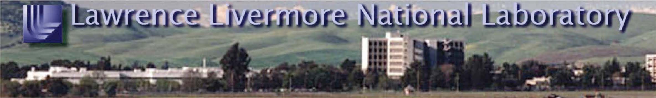

AGENDA Panel on Light Source Facilities

NATIONAL SCIENCE FOUNDATION (NSF)

Wednesday-Thursday, January 9-10, 2008
Wednesday, January 9, 2008
7:15 a.m. Pickup at the Hilton Garden Inn and LLNL Driver
transport to LLNL Met by Protocol

7:30 a.m. Arrival and Badging Westgate Badge Office
Transport to Bldg. 170 LLNL Driver

8:00 a.m. Opening Remarks Venky Narayanamurti
Bldg. 170, Rm. 1091

8:15 a.m. Federal Agency Perspectives Tony F. Chan – NSF (PDF)
Pedro A. Montano -DOE (PDF)
Jeremy M. Berg –NIH (PDF)

10:00 a.m. Break

10:15 a.m. New Light Source Facilities
Upgrades to 3rd Generation Synchrotrons
- NSLS II Steven Dierker -BNL (PDF)
- APS J. Murray Gibson -APS (PDF)

11:15 a.m. Beyond 3rd Generation
- Overview Samuel Krinsky -BNL (PDF)
- Laser-based accelerator R&D Roger W. Falcone -UC Berkeley (PDF)
needs

12:15 p.m. Working Lunch Kathryn L. Beers -OSTP

1:30 p.m. Beyond 3rd Generation (continued)
- LCLS Jerome B. Hastings -SLAC (PPT)
- ERL Concept Sol M. Gruner -Cornell (PDF)
- XFEL Concept Joseph J. Bisognano –Wisconsin (PDF)
David E. Moncton – MIT (PDF)
Host: Cherry A. Murray, Associate Director, Science and Technology
Protocol: Rose A. O’Brien, (925) 423-6820, Cell: (925) 519-0959, Pager: 800-200-6472, E-mail: obrien12@llnl.gov
Carrie Martin, (925) 424-4175
Clearance: Unclassified Agenda Date: January 3, 2008

Panel for Light Source Facilities (NSF) Page 2
Wednesday, January 9, 2008 (Continued)
3:45 p.m. Break
4:00 p.m. Supporting Technologies
— Optics, Detectors and Data Gopal Shenoy -APS (PDF)
Challenges

4:30 p.m. Alternative Technologies
— Table-top Synchrotrons Robert L. Byer -Stanford (PDF)

5:00 p.m. Partnerships
— Chem-Mat-CARS P. James Viccaro -U Chicago (PDF)
— Magnets & Light Sources Gregory S. Boebinger –NHMFL (PDF)
— J-Lab Activities George R. Neil -J-Lab (PDF)

Transport non-committee members to LLNL Driver
the Central Cafeteria (Bldg. 471)

6:15 p.m. Closed session NSF committee members only

Transport non-committee members to LLNL Driver
the Central Cafeteria (Bldg. 471)

6:45 p.m. Working dinner Central Cafeteria – Bldg. 471
— Perspective from Europe Yves Petroff -ESRF (PPT)

8:00 p.m. Transport to the Hilton Garden Inn LLNL Driver

Thursday, January 10, 2008
7:30 a.m. Pickup at the Hilton Garden Inn and LLNL Driver
transport to LLNL Met by protocol

8:00 a.m. Opening Remarks Venky Narayanamurti
Bldg. 170, Room 1091

8:10 a.m. Potential Users
— Condensed Matter Science Simon Mochrie -Yale P. (PPT)
— Chemistry and Materials James Viccaro -U Chicago (PDF)
— Biological & Health Sciences Dagmar Ringe- Brandeis (PDF)
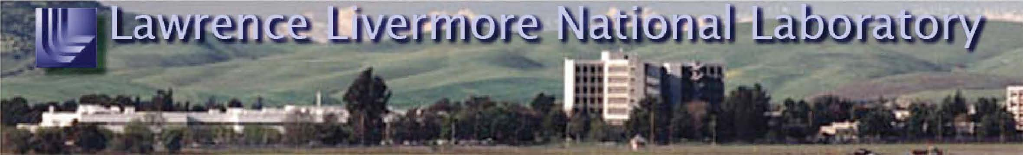

Panel for Light Source Facilities (NSF) Page 3

— AMO Physics Phillip H. Bucksbaum -Stanford (PDF)

Thursday, January 10, 2008 (Continued)
10:30 a.m. Break

10:45 a.m. Panel Discussion – Focus on Key Issues Narayanamurti, Murray;
Agency Representatives;
Science Community
Representatives

12:00 p.m. Working Lunch: NIF as a User Facility Edward I. Moses

1:30 p.m. Transport to Bldg. 581 LLNL Driver

1:45 p.m. National Ignition Facility (NIF) Tour* Edward I. Moses

2:45 p.m. Transport non-committee members to LLNL Driver
the Hilton Garden Inn Non-committee members

3:00 p.m. Next Steps NSF committee members only
— What do we need to do now Bldg. 581, Rm. 100
— Identify Site Venues, Dates
and Subgroups
— Plans For Next Meeting and

Report Writing
4:00 p.m. Wrap-up By Invitation

4:30 p.m. Adjourn

Transport committee members to LLNL Driver
the Hilton Garden Inn

*NIF clothing requirements:
The following clothing restrictions apply; NO sleeveless shirts, shorts, capri pants, skirts or dresses. NO footwear with open toe, open backs, sandals or high heels. Tennis shoes and loafers are acceptable.

Panel for Light Source Facilities (NSF) Page 4
Committee Members
Venkatesh Narayanamurti (Chair) Harvard University
Helen Edwards Fermi National Accelerator Laboratory
Kenneth Evans-Lutterodt Brookhaven National Laboratory
Michael L. Klein University of Pennsylvania
Michael L. Knotek Consultant
W. Carl Lineberger University of Colorado at Boulder
Keith Moffat University of Chicago
Cherry A. Murray (Co-Chair) Lawrence Livermore National Laboratory
Monica Olvera de la Cruz (liaison to MPSAC) Northwestern University
Elsa Reichmanis Bell Laboratories – Lucent Technologies
Mary Jane Saunders Cleveland State University
Charles V. Shank University of California, Berkeley
Richard York Michigan State University
NSF Staff
W. Lance Haworth, Director of the Office of Integrative Activities
G.X. Tessema, Division of Materials Research
Lawrence Livermore National Laboratory Operated by the Lawrence Livermore National Security, LLC for the 7000 East Avenue · Livermore, CA 94550 Department of Energy’s National Nuclear Security Administration

