National Science Foundation

Advisory Committee for International Science and Engineering

# March 19-20, 2012

# **MEETING MINUTES**

Members Present:

Saifur Rahman, Chair AC-ISE

Howard Alper

Peter Arzberger

Vicki Colvin (participation by phone on March 19)

Jean-Pierre Ezin

Chuck Kennicutt

Steven W. McLaughlin

George Middendorf, CEOSE Liaison (participation at NSF on March 19)

Roddam Narasimha

Jeanne L. Narum

Maresi Nerad

Efrain O'Neill-Carrillo

Anne Petersen

[A list of Advisory Committee Members’ affiliations is attached.]

The Advisory Committee for International Science and Engineering (AC-ISE) met at the National Science Foundation, Arlington, Virginia in Stafford II Room 595 on March 19 and 20, 2012. The meeting agenda is attached.

**Monday March 19, 2012**

Welcome, Review of Meeting Agenda and Objectives

Dr. **Machi F. Dilworth**, Director, Office of International Science and Engineering (OISE), welcomed the public, NSF staff, and new and continuing members of the Advisory Committee.

Dr. **Saifur Rahman**, Chair, AC-ISE, reviewed the meeting agenda and objectives. He emphasized that the AC-ISE is charged to focus on international science and engineering for the entire National Science Foundation. He noted that Dr. Susan McCouch was not able to participate in the meeting.

International Activities across NSF

Dr. Dilworth summarized the wide variety of high-level international representational activities and bilateral and multi-lateral funding programs supported by each of the NSF directorates and offices.

She described the status of three new international initiatives. The recently launched Partnerships for Enhanced Engagement in Research (PEER) program with the U.S. Agency for International Development (USAID) invites developing country scientists to apply for funds to support research and capacity-building activities in partnership with their NSF-funded collaborators on topics of importance to USAID (e.g., water, climate, biodiversity, disaster mitigation, renewable energy). In response to the first PEER competition, nearly 500 proposals were received from scientists in 63 developing countries. All NSF directorates and offices had U.S. awardees who were identified as collaborators on PEER proposals.

The NSF-wide Science Across Virtual Institutes (SAVI) funding opportunity is designed to serve as "glue" to facilitate building of solid foundations for virtual institutes between teams of U.S. and foreign researchers, engineers, and educators. The U.S. side of a team can consist of either an existing NSF center/institute awardee or a virtual center/institute consisting of multiple investigators holding individual NSF awards with shared research/education interests. NSF funds will support U.S. participants; international partners are to be supported by their own funding sources.

At the request of the White House, NSF will convene a global summit of the Heads of Research Councils on May 13-15, 2012. The summit has two primary goals: (1) endorse a statement of principles on merit review, and (2) host the inaugural meeting of the Global Research Council. The long-term objective of the Council is to foster multilateral research collaboration across continents to benefit both developing and developed nations.

FY 2013 Budget Request

Dr. Dilworth reported that the President submitted a FY 2013 budget request to Congress on February 13, 2012. Dr. Subra Suresh unveiled NSF’s FY 2013 request at a public meeting held at NSF on the same day. The NSF request is $7,373 billion, a 4.8 percentage increase over the FY 2012 estimate. A central feature of the FY 2013 budget request is seven priority areas under the umbrella of OneNSF. Dr. Dilworth invited three NSF executives to summarize priorities with strong international characteristics.

Dr. **Tim Killeen**, Assistant Director for Geosciences, described Science, Engineering, and Education for Sustainability (SEES), including NSF competitions and related portfolios, the Belmont Forum International Opportunities Fund, and a ten-year Global Research Initiative.

Dr. **Joan Ferrini-Mundy**, Assistant Director for Education and Human Resources discussed

Expeditions in Education (E2), including trends and challenges, and E2 objectives and focus topics for FY 2013.

Dr. **Alan Blatecky**, Office Director for the Office of Cyberinfrastructure summarized Cyberinfrastructure Framework for 21st Century Science and Engineering  (CIF21), including the broad scope of CIF21 initiatives for advanced computing infrastructure.

Reports from Overseas Offices

Dr. **Carmen Huber**, Head of the NSF Europe Office, summarized the role of NSF overseas offices as facilitation (to promote collaboration), representation (as a liaison between NSF and others), and reporting on S&E developments in the region. The overseas offices are affiliated with U.S. embassies and do not manage NSF program funds. Dr. Huber presented statistics on the S&E landscape in Europe and outlined some opportunities and challenges.

Dr. **Bill Chang**, OISE Program Coordinator for the East Asia and Pacific region, gave a progress report on innovation in China. He described China’s implementation of the 12th five-year plan and presented related statistics and priorities. The Plan emphasizes “created in China,” not “made in China.” Dr. Chang summarized NSF supported programs in China including, supporting research infrastructure, and addressing global challenges.

Dr. **Anne Emig**, Head of the NSF Tokyo Office, emphasized that the Tokyo Office serves the entire East Asia region, except China, with greatest focus on Korea and Singapore. The Office was established in 1960, employs two local staff, and is located in the U.S. Embassy in Tokyo. Dr. Emig characterized the Office’s support for U.S. research as sharing timely information, expanding opportunities to leverage resources, and supporting NSF directorates and U.S. researchers and students. She described events related to the March 11, 2011 earthquake and tsunami and how the NSF Office acted to facilitate research and collaborations. She elaborated on NSF programs and activities in the region, including the Integrated Ocean Drilling Program, Partnerships for International Research and Education (PIRE), and other programs involving student and postdoctoral participants.

Transforming International Research and Education Partnerships

Dr. **Rahman**, moderated a Committee discussion on international partnerships. He stimulated the discussion with a series of statistics on the changing STEM landscape in the global context and “forcing functions” from other nations. He emphasized the theme of leadership through partnership.

Dr. **Peter Arzberger**, AC-ISE Member, summarized the research community perspective. He pointed out shifts in science funding among nations, increases in collaborations, declines in U.S. student performance, and need for international experience among undergraduates. The rationale and value of international collaboration varies for each discipline, but there are common elements for successful collaboration. The “ingredients to collaboration” include participant motivation and resources, shared scientific interests, incremental steps, mutual trust, enduring commitment, effective communication, and personal interactions.

Committee members highlighted instances of effective collaborations in numerous countries, noting variations in strategies and cultural values. Members identified emerging research on how to make collaboration work, and emphasized the need for meaningful metrics. The importance of educational experiences and curriculum development were stressed. Due to time constraints, Dr. Arzberger deferred the conclusion of his remarks to the Tuesday session.

Dr. **Vicki Colvin**, AC-ISE Member, summarized the university perspective. She participated by phone. Dr. Colvin noted that U.S. research universities are under severe financial pressure and are facing fundamental changes in educational delivery. She characterized the globalization of research using top-down and bottom-up examples from Rice University. Best practices included: incentives and leadership, focus on geographic regions, realistic cost estimates, linking research and education, and leveraging technologies.

Committee members noted many similarities on their own campuses. Opportunities for industry partnerships in international engagements were suggested. Costs, benefits, and constraints of overseas/satellite campuses were noted.

Meeting with the Director of the National Science Foundation

Dr. **Subra Suresh** reported on his budget testimony before Congress and indicated that there is bipartisan support for NSF. He stated that NSF’s FY 2012 budget was reasonably good under the circumstances, with a 2.5 percentage increase over the FY 2011 level. The President’s FY 2013 Budget Request to Congress for NSF is $7,373 million, a 4.8 percent increase over the FY 2012 estimate.

Dr. Suresh summarized his framework for “OneNSF” emphasizing NSF’s mission to serve many diverse communities, while preserving each community’s culture and values. One goal is to take best practices from the corners of NSF to elevate to the agency level and give them a “bully-pulpit” to get something major accomplished. The recently announced Science Across Virtual Institutions (SAVI) is an example of using best practices to get the attention of the leadership of the top institutions and to leverage resources. He stressed that international activities are at the core of the OneNSF framework, and that OISE, in collaboration with NSF’s disciplinary programs, has a central role in encouraging and supporting international engagements.

Dr. Suresh thanked AC-ISE for their input following the April 2011 meeting, and looked forward to hearing additional input and advice on how to further strengthen international engagements.

Members pointed out that international partnerships have revenue implications for U.S. institutions, especially in terms of tuition payments from foreign students. Dr. Suresh responded that NSF has a major role to play in nurturing the science and engineering talent of the future. Doing so attracts science talent to come to the U.S. from other countries and provides leadership for scientific collaboration. He characterized the international transfer of students not as “brain drain” but as “brain circulation.”

Dr. Suresh noted that a Memorandum of Understanding (MOU) with every country is not feasible and NSF needs to consider regional umbrellas of broader engagements. One approach is to have a “one-stop-shop” for all countries in a region to leverage resources and experience. NSF is looking at co-funding and leveraging as critical approaches for One NSF. He cited funding of the Atacama Large Millimeter Array (ALMA) in Chile as an example, where NSF contributes about a third, the European Union (EU) a third, and the remainder comes from Asia and other sources.

Dr. Suresh announced that the heads of science funding agencies from about 46 nations will meet at NSF in May 2012 for the Global Summit on Merit Review to develop a common understanding of principles and to establish a Global Research Council (GRC) to facilitate substantive collaborations. He emphasized that the GRC is intended to reduce barriers to multi-national collaboration, not to provide direct research funding. The GRC may also address international aspects of research integrity and ethics.

Dr. **George Middendorf** commented that U.S. interests over both the short and long term would be well served by fostering recruitment and retention of minorities and members of underrepresented groups, and supporting programs in "underrepresented continents" (Africa and South America) as a means of recruiting students from underrepresented groups in the U.S.

Dr. Ezin added that the ACP (Africa – Caribbean – Pacific) group which constitutes an entity collaborating with EU in many domains, including STEM, could be considered by NSF too for its international engagements.

Several AC-ISE members commented on the important role of the Office of International Science and Engineering (OISE) as a champion for international activities at NSF and for generally supporting international relationships in various venues. Dr. Suresh remarked that there are vital functions that need to occur in a central office like OISE, such as interactions with the Department of State, foreign embassies, and overseas offices.

AC-ISE members asked about systematically evaluating NSF’s international activities. Dr. Suresh remarked that a comprehensive inventory of NSF’s diverse international activities is needed. Dr. Dilworth replied that evaluation is wide-spread at NSF and that OISE is working with other directorates on effective approaches.

Summary of Afternoon Discussions

Dr. **Mahlon Kennicutt** succinctly summed up the discussions by noting that NSF must take a leadership role to ensure program success, and that if you don’t partner, then you lose leadership.

The Committee approved the minutes of the April 2011 AC-ISE meeting.

**Tuesday March 20, 2012**

Continuation of Advisory Committee Member Discussion on Transforming International Research and Education Partnerships

Dr. Rahman invited Dr. Arzberger to continue his remarks from Monday about the changing landscape of global research. Dr. Arzberger emphasized that science is borderless and that NSF should strive to remove barriers to international collaboration, cooperation, and coordination. He cited a Royal Society publication, *Knowledge, Networks and Nations: Global scientific collaboration in the 21st century*, March 2011, noting that the architecture of world science is changing with the expansion of global networks. International activities and collaborations should be embedded in national science and innovation strategies, including NSF’s, so that domestic science is best placed to benefit from the intellectual and financial leverage of international partnerships. He described four levels of strategic focus: (1) NSF priority areas, (2) programmatic area decisions, (3) human capital investments, and (4) bilateral and multi-lateral partnerships. Collaboration enhances the quality of scientific research, improves the efficiency and effectiveness of that research, and is increasingly necessary as the scale of both budgets and research challenges grow. However, the primary driver of most collaboration is the scientists themselves, seeking to work with the best people, institutions, and equipment which complement their research, wherever their location. In identifying future opportunities and centers of excellence, he invoked a hockey metaphor, “skate to where the puck is going to be.” Members identified several research areas and countries with notable research capabilities.

Some committee members noted that OISE is in position to serve as a champion for agency-wide international activities. Dr. Dilworth commented that OISE is a focused office that coordinates and manages international activities across the Foundation. She urged the Committee to suggest new ways of promoting international engagements and investing limited resources.

Dr. **Howard Alper** remarked that research communities in developing countries often feel undervalued and, although their research infrastructure is often weak, the intellect and creativity of researchers and educators is strong. Mechanisms need to be developed to link and engage them as equal partners. A multi-tiered (top-down and bottom-up) strategy is appropriate. Other members endorsed this sentiment.

Dr. **Steven McLaughlin** suggested adding a preamble to the Committee’s Principles for International Engagement that would capture at a high level why a global strategy for NSF is important. He offered to draft the text for AC-ISE consideration.

Several members commented about the number and locations of NSF’s overseas offices. Dr. Dilworth replied that maintaining permanent on-site offices is costly and that several options for having a “presence” in a country or region are being considered. An assessment of current overseas offices and alternatives is being planned.

Members suggested ways for encouraging and optimizing student science experiences abroad including language and cultural sensitivity training, industry employment opportunities, and expanding the duration of overseas experiences. They noted student participation is often restricted by institutional time-to-degree guidelines, specific course requirements, and grant durations of sponsoring researchers.

Several members expressed the need for a comprehensive inventory of international activities at NSF. Dr. Dilworth replied that a diverse range of international activities is being supported through individual grants, and OISE will attempt to capture this information in a meaningful way.

Recommendations and Action Plans and

Around the Table and Wrap-up

Dr. Rahman challenged the committee to express a vision of NSF’s global engagement in 2020 and identify ways to get there. Rather than pointing to where a center of excellence might be located, the committee should suggest a process for selecting topical areas for investment. The committee members responded with the following suggestions:

* Being a global leader does not mean being first on everything all the time. It is more important to be an active participant at the table. Interactions should involve professional respect, common interests, mutual benefits, and shared responsibility.
* Focus on post-graduates, where the cost-benefit is clearer.
* Utilize foreign cultures and communities of partners for mutual benefit.
* Articulate the outcomes gained from international investments.
* Sustain funding over long timeframes to ensure enduring partnerships.
* Expand and be more aggressive on educational initiatives while recognizing different expected outcomes at each level. It’s not just the science learned, but the perspective gained and maintained from international experiences.
* Engage undergraduates in summer research experiences abroad.
* Assess benefits and opportunities of overseas offices in the context of NSF’s broad international activities.
* Utilize overseas offices to gauge the benefits of engagements in various fields.
* Expand partnerships with other Federal agencies. Several examples were cited including, USAID (PEER), DOE (energy efficiency research), EPA (Panel on Sustainability), and ONR (sea-level rise and renewable energy).
* Engineering Research Centers with international components can be important for establishing “big bets.”
* Establish performance indicators that are both compelling and defensible for determining success.
* Support research on understanding long-range impacts of international experiences and utilizing them to improve activities.
* Consider sponsoring a decadal survey of international opportunities involving community input.
* Encourage AC-ISE members to interact with professional societies and associations on international matters including organizing discussion sessions or town hall type meetings.
* Organize a virtual meeting of the AC-ISE before the Fall 2012 meeting to continue the dialogue.

The meeting of the NSF Advisory Committee for International Science and Engineering adjourned at 11:50.

**MEMBER AFFILIATIONS**

**NATIONAL SCIENCE FOUNDATION**

**ADVISORY COMMITTEE FOR**

**INTERNATIONAL SCIENCE AND ENGINEERING (AC-ISE)**

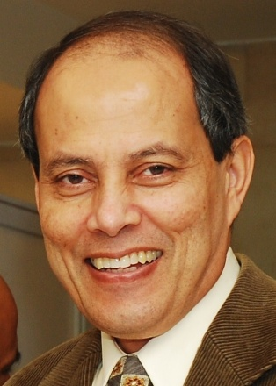***Dr. Saifur Rahman****, Chair, AC-ISE*

Editor-in-Chief, IEEE Transactions on Sustainable Energy

Joseph R. Loring Professor

Director, Virginia Tech Advanced Research Institute

Arlington, VA

AC-ISE Term: October 1, 2007 – September 30, 2013

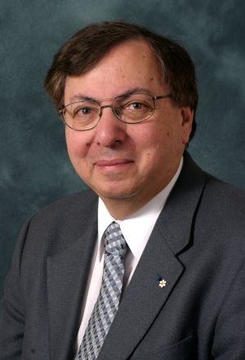***Dr. Howard Alper***

Chair / Président Science, Technology and Innovation Council /

Conseil des sciences, de la technologie et de l'innovation

Ottawa, Canada

AC-ISE Term: **January 1, 2010 - December 31, 2012**

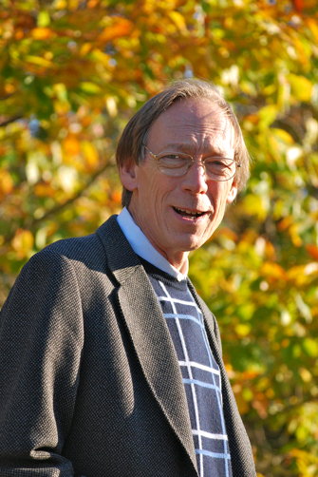***Dr. Peter Arzberger***

Director, National Biomedical Computation Resource

Chair, PRAGMA Steering Committee

University of California, San Diego   
La Jolla, CA

AC-ISE Term: January 1, 2012 - December 31, 2014

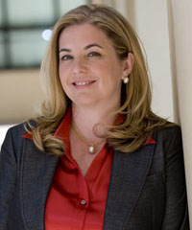***Dr. Vicki Colvin***

Vice Provost for Research

Kenneth S. Pitzer-Schlumberger Professor of Chemistry

Professor of Chemical & Biomolecular Engineering

Rice University

Houston, TX

AC-ISE Term: January 1, 2012 - December 31, 2014

*[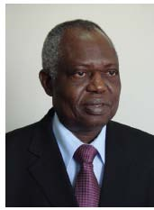](http://au.int/en/dp/hrst/commissioner/biography)****Dr. Jean-Pierre Onvêhoun Ezin***

African Union Commissioner for Human Resources, Science and Technology

African Union Headquarters

Addis Ababa, Ethiopia

AC-ISE Term: **January 1, 2010 - December 31, 2012**

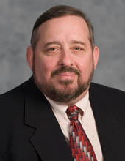***Dr. Mahlon C. Kennicutt II***Professor  
Department of Oceanography  
Texas A&M University

College Station, TX

AC-ISE Term: January 1, 2012 - December 31, 2014

*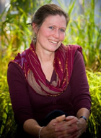****Dr. Susan McCouch***

Professor of Plant Breeding and Genetics and of Plant Biology

Cornell University

Ithaca, NY

AC-ISE Term: January 1, 2012 - December 31, 2014

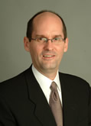

***Dr. Steven W. McLaughlin***

Vice Provost for International Initiatives

Steven A. Denning Chair in Global Engagement

Georgia Institute of Technology

Atlanta, GA

AC-ISE Term: January 1, 2012 - December 31, 2014

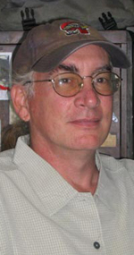***Dr. George Middendorf****, CEOSE Liaison*

Graduate Professor

Department of Biology

Howard University

Washington, DC

AC-ISE Term: April 18, 2011 – January **31, 2013 (**CEOSE)

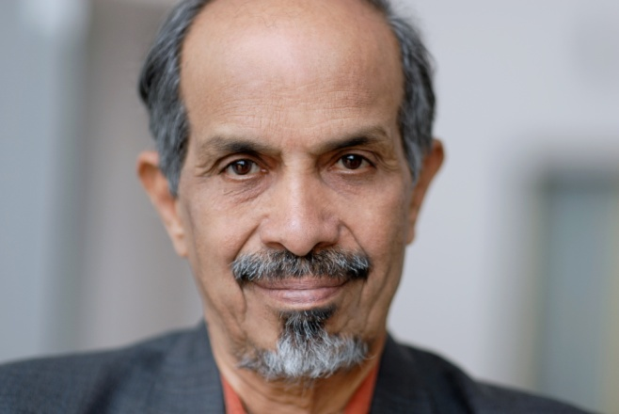***Dr. Roddam Narasimha***

[Engineering Mechanics Unit](http://www.jncasr.ac.in/emu/)

[Jawaharlal Nehru Centre for Advanced Scientific Research](http://www.jncasr.ac.in/)

Bangalore, India

AC-ISE Term: **January 1, 2010 - December 31, 2012**

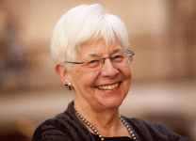***Ms. Jeanne L. Narum***

Founding Director, Project Kaleidoscope (PKAL)

Senior Fellow, PKAL/Association of American Colleges & Universities

Director, The Independent Colleges Office

Washington, DC 20036

AC-ISE Term: January 1, 2010 – December 31, 2012

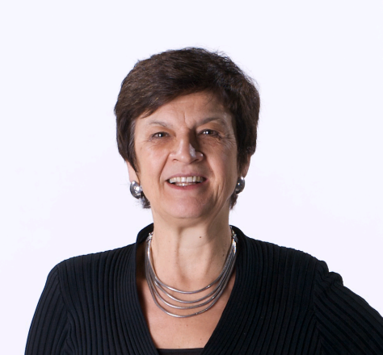***Dr. Maresi Nerad***

Director, Center for Innovation and Research in Graduate Education (CIRGE)   
Professor Extraordinary, University of the Free State, South Africa  
Associate Professor, Educational Leadership and Policy Studies   
College of Education

University of Washington   
Seattle, WA 98195-3600

AC-ISE Term: January 1, 2010 – December 31, 2012

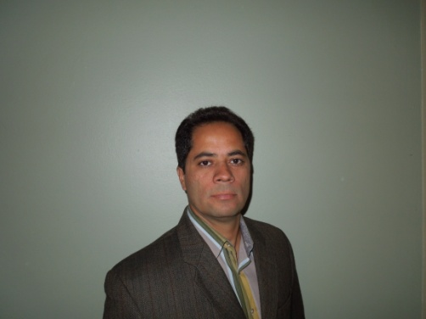***Dr. Efraín O'Neill-Carrillo, PE***

Associate Director, CIVIS: Center for Resources in General Education

Director, Power Quality & Energy Studies Laboratory

Professor, Electrical & Computer Engineering Department

University of Puerto Rico-Mayagüez (UPRM)

Mayaguez, Puerto Rico

AC-ISE Term: January 1, 2012 - December 31, 2014

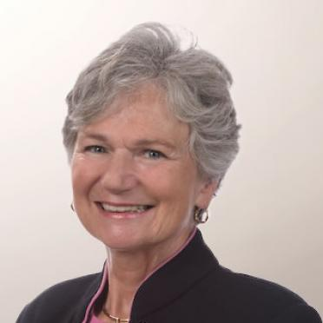***Dr. Anne C Petersen***

President, Global Philanthropy Alliance and

Research Professor, Center for Human Growth and Development

University of Michigan

Ann Arbor, MI 48109

AC-ISE Term: January 1, 2012 - December 31, 2014

**AGENDA**

**NATIONAL SCIENCE FOUNDATION**

**ADVISORY COMMITTEE FOR**

**INTERNATIONAL SCIENCE AND ENGINEERING (AC-ISE)**

***March 19-20, 2012***

*National Science Foundation*

*4201 Wilson Boulevard, Arlington, Virginia*

***Stafford II Room 595***

**Monday, March 19, 2012**

**8:30-8:45 Welcome, Review of Meeting Agenda and Objectives**

*Machi Dilworth, Director, Office of International Science and Engineering*

*Saifur Rahman, Chair, AC-ISE*

**8:45-10:15 International Activities across NSF**

*Machi Dilworth*

10:15-10:30 Break

**10:30-11:30 FY 2013 Budget Request**

*Machi Dilworth*

**11:30 – 12:15 Reports from Overseas Offices**

*Carmen Huber, Head, NSF Europe Office*

*Anne Emig, Head, NSF Japan Office*

*Emily Ashworth, Head, NSF Beijing Office*

12:15- 1:30 Lunch

**1:30-3:30 Transforming International Research and Education Partnerships**

*Saifur Rahman, Moderator, Introduction to the changing STEM landscape*

*Vicki Colvin, Lead Discussant, University/college perspectives*

*Peter Arzberger, Lead Discussant, Research community perspectives*

3:30-4:00 Break

**4:00-5:00 Meeting with Director of the National Science Foundation**

*Subra Suresh, Director, NSF*

*Cora Marrett, Deputy Director, NSF*

**5:00-5:15 Summary of afternoon discussions**

*Saifur Rahman*

**Tuesday, March 20, 2012**

**8:30-10:00 Continuation of Advisory Committee Member Discussion on**

**Transforming International Research and Education Partnerships**

*Saifur Rahman*

10:00-10:15 Break

**10:15-11:15 Recommendations and Action Plans**

*Saifur Rahman*

**11:15-12:00 Around the table and Wrap-up**

*Saifur Rahman*

*Machi Dilworth*

12:00 Adjourn